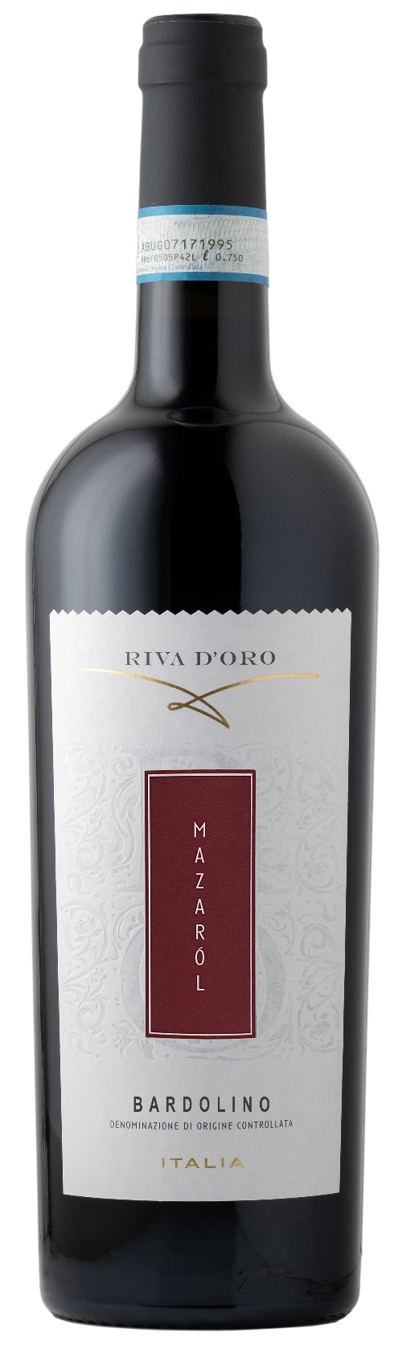
BARDOLINO DOCG – MAZAROL

Grape: Corvina 60%, Rondinella 30%, Molinara 10%
Alc. Vol.%: 12
Vintage: 2024
Residual sugar g/l: 5,1
Total acidity g/l: 5,2
Region: Veneto
Production zone: Vineyards in the Bardolino area
Capacity: 750ml, 1500ml

CHARACTERISTICS

Vinification: Gentle pressing of the grapes, followed by peel maceration in steel tanks at a controlled temperature
Aging: In steel tanks until bottling
Yield per ha: 13000kg
Colour: Lightly shiny red
Bouquet: Pleasantly fresh, with a morello cherry note
Flavour: Smooth, light and constant

SERVING SUGGESTIONS

Best enjoyed with pasta and white meat.
Serving temperature 16-18 °C
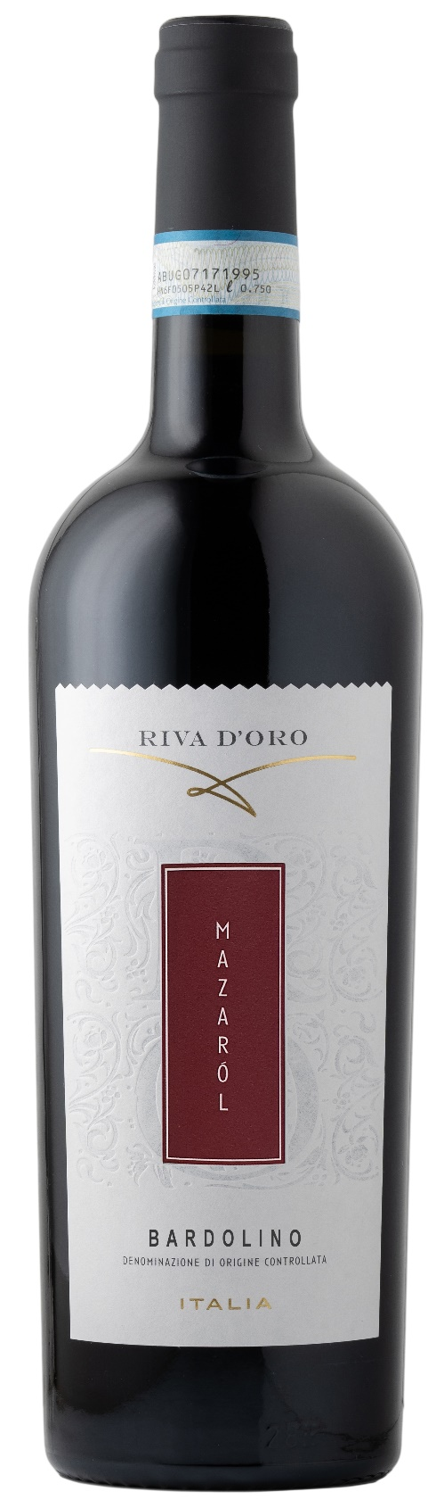
TECHNICAL INFORMATION / PALLETIZING

Size 750ml:
Article Nr. V09001A
GTIN-13 bottle 8017868000693
GTIN-13 carton 8017868004240
Closure Cork
Bottles / carton 6 bottles
Pallet size 80x120cm
Cartons/layer 21
Cartons/pallet 105
Kg/carton 7,8
Kg/pallet 840

Size 1500ml:
Article Nr. V09002B
GTIN-13 bottle 8017868002437
GTIN-13 carton 8017868004493
Closure Screwcap
Bottles / carton 6 bottles
Pallet size 80x120cm
Cartons/layer 14
Cartons/pallet 56
Kg/carton 13,4
Kg/pallet 960

Contains sulphites
GMO Free
Revisione 01. 14.05.2026

